**User Guide**

**Lumen Detector and Quantification Software**

**Article: Deconstructing the principles of ductal network formation in the pancreas**

**How to install the software (windows and mac version):**

**Step 1: Download executable from** [**https://github.com/gopalrk/Lumen_Detector_and_Quantification**](https://github.com/gopalrk/Lumen_Detector_and_Quantification)

**Step2: Double click on the Lumen_Detector_and_Quantification.exe on windows and Lumen_Detector_and_Quantification.app on mac. Follow the further instruction**

**Step 3: After the successful software installation, user will see software icon on their desktop**

**How to use the software:**

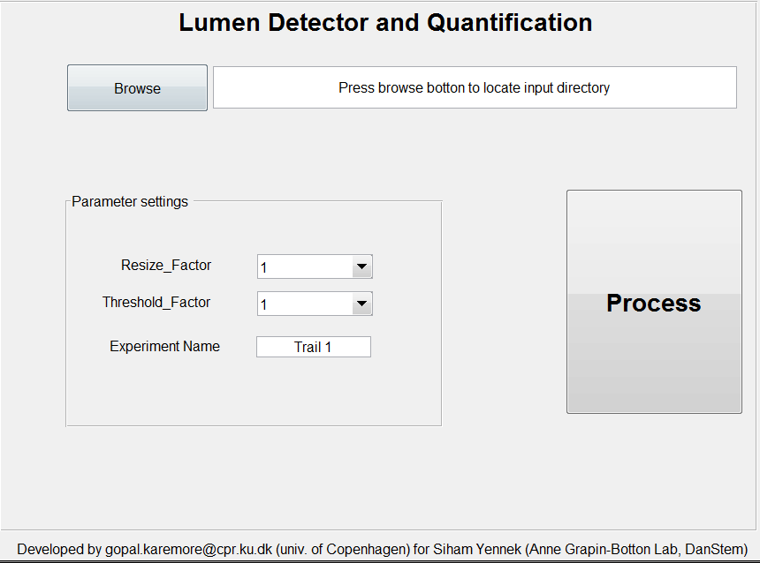

**Step 1: Browse the location of your image files (only tiff file format is supported)**

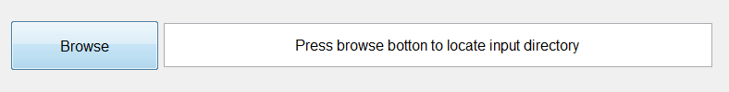

**Note: If you have vendor specific image file format, use FIJI bioformat plugin to export it to tiff image file format.**

**Step 2: Parameter Settings:**

**Resize_factor: Using this setting, user can downsample the original image inorder to speed up the segmentation process.**

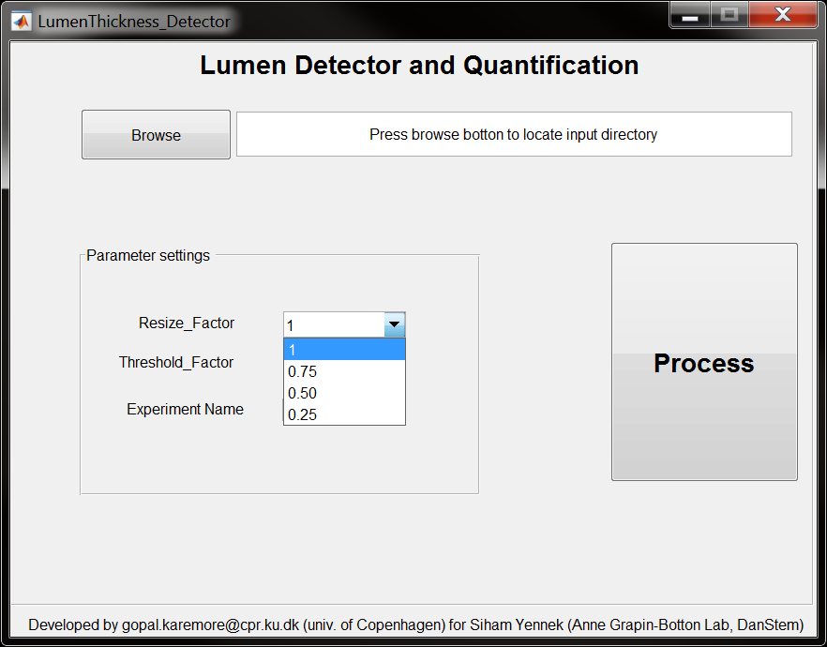

**Threshold_Factor: This is threshold factor required for segmentation of the lumen using Otsu algorithm. This threshold fator will be multiplied to Otsu threshold inorder to tune the segmentation.**

**Note: User will have to set this factor depending on the particular image**

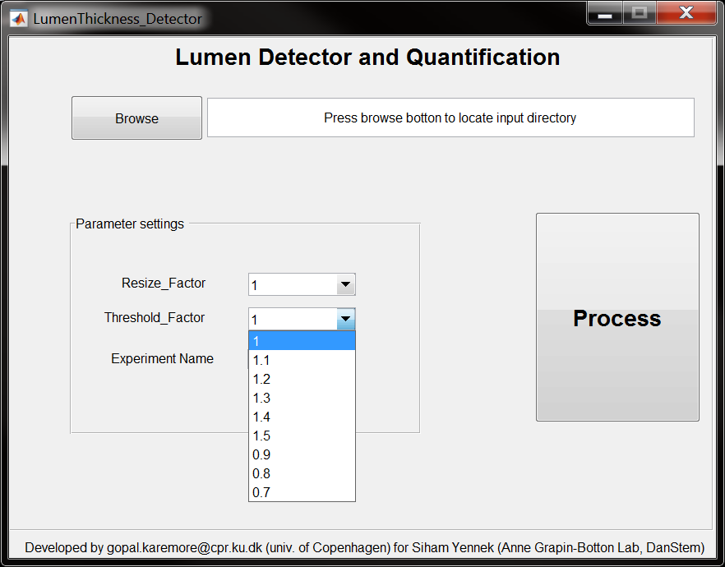

**Experiment Name:**

**This is name of output excel file generated by the software containing the results of segmentation.**

**Note: output directory “OP” will be created automatically under the input path. OP directory contains the snapshots of segmentation results as well as the excel sheet.**

**Step 3: Process**

**Click on “Process” button to start the segmentation and quantification**

**Structure of output Excel file:**

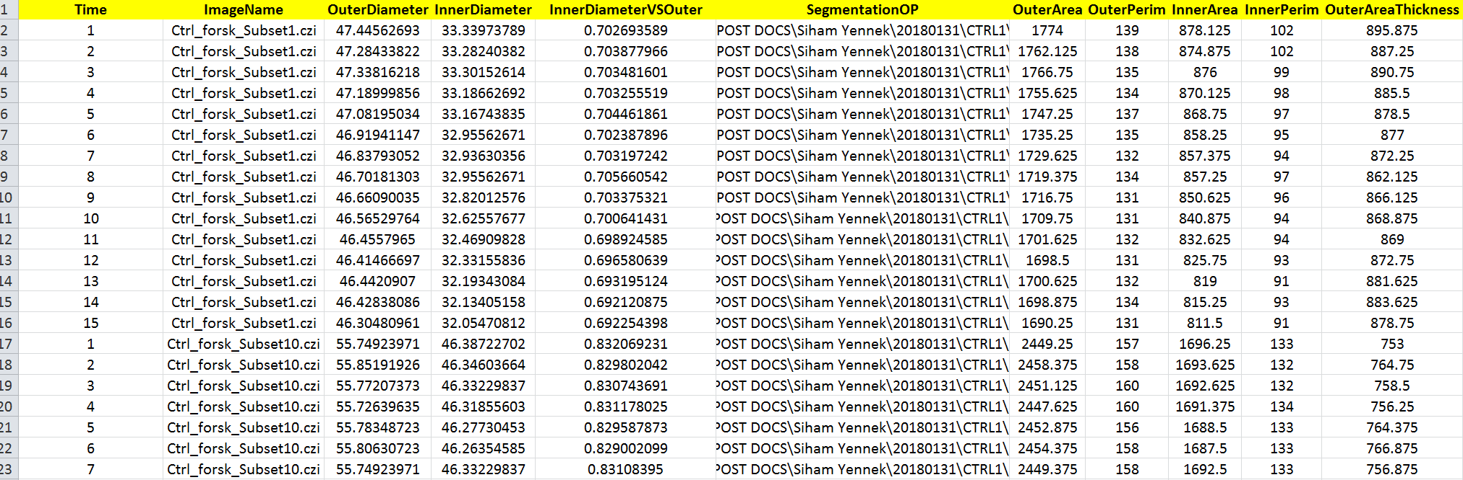

**Meaning of various column features:**

**OuterDiameter: Outer diameter of the disk which is fitted over the segmented lumen.**

**InnerDiameter: Inner diameter of the disk which is modeled over the segmented lumen.**

**InnerDiameterVsOuter: ratio between Inner Vs Outer diameters**

**SegmentationOP: Location of snapshot of segmented images**

**Outer Area: Area of disk fitted over the outer lumen surface**

**Inner Area: Area of disk fitted over the inner lumen surface**

**Outer Perimeter: Perimeter of fitted disk over the outer lumen surface**

**Inner Perimeter: perimeter of fitted disk over the inner lumen surface**

**Outer area Thickness: Thickness of the cell layer**